Physics 30H Lesson 41H Fluid Dynamics

The three common states or phases of matter are solid, liquid and gas. Solids are any objects that maintain a fixed shape and fixed size. Even under enormous forces or pressures, solids maintain their shape and size. A liquid does not maintain a fixed shape, rather it assumes the shape of the container which holds it, but like a solid, a liquid is not easily compressible and will maintain its volume unless subjected to enormous forces or pressures. A gas has neither a fixed volume nor shape and will expand to fill its container. There is a fourth state of matter, the plasma state, which occurs at very high temperatures. We will be focusing primarily on the three ordinary states of matter.

Fluids are defined materials that can flow. Since liquids and gasses do not maintain a fixed shape, they each have the ability to flow and are thus considered fluid. The discussion of fluids has two parts:

Statics – fluids at rest
Dynamics – fluids in motion

Fluid Density

It is often said that iron is “heavier” than wood. This is not exactly true since a large log clearly weighs more than a nail. What we should really say is that iron is more “dense” than wood. The density (ρ) of a substance is defined as its mass (m) per unit volume (V):

ρ = m/V (units kg/m³)

Equal volumes of different substances generally have different masses, so the density depends on the nature of the material. (Note: The density of a substance also depends on temperature and pressure, but for our purposes we will always assume 0°C.)

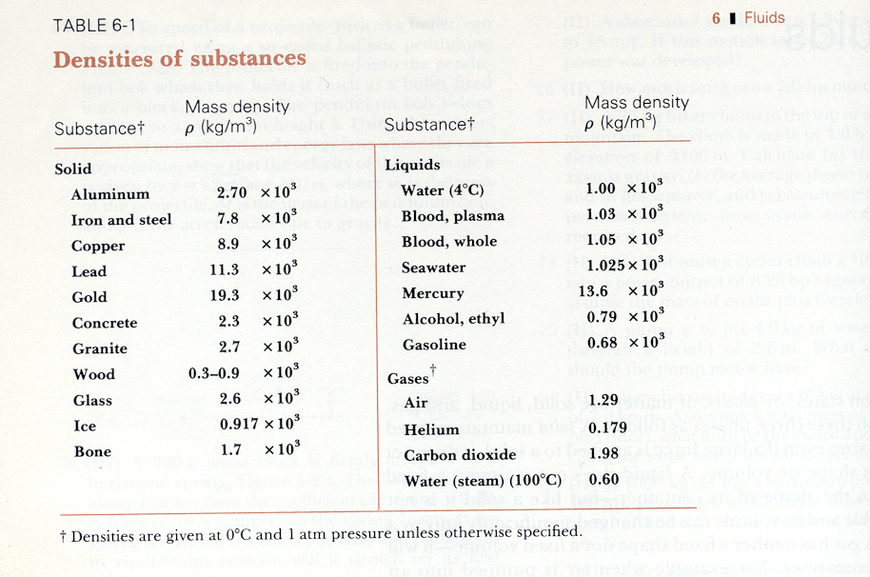
Example
What is the mass of a lead sphere of radius 0.500 m?

The volume of a sphere is given by V = 4/3πr³

Since: m = ρV = ρ (4/3πr³) = (11 300 kg/m³) 4/3π (0.500m)³

m = 5910 kg

A convenient way to compare densities is to use the concept of specific gravity. The specific gravity of a substance is the ratio between the density of the substance to the density of water at 4°C. Specific gravity (SG) is a pure number without dimensions or units. For example, diamond has a SG of 3.52 since the density of diamond is 3.52 times that of water at 4°C.

Pressure

Most people who have changed a flat tire know something about pressure. The final step in fixing a flat is to inflate the tire to the proper pressure. An under inflated tire is soft because it contains an insufficient number of molecules of air to push outward against the rubber and give the tire a solid feel. When the tire is inflated to the proper pressure, the air pushes outwards with enough force to give the tire the shape needed to roll properly. The random collisions of wandering air molecules within a tire allow the air to exert a force on the inner walls of the tire. The concept of pressure takes into account the force, as well as the area over which the force acts.

Pressure is defined as a a force per unit area, where the force (F) is understood to be acting perpendicular to the surface area (A):

Pressure = P = F/A units = N/m² = pascal (Pa)

The pressure of 1Pa is a small amount. Common situations involve pressures of ∼10⁵ Pa.

It is an experimental fact that a fluid exerts a pressure in all directions (ask a diver). At a particular point for a fluid t rest, the pressure must be the same in all directions. This must be true, because if it weren’t, the net force would not equal zero and the fluid would flow until it did reached equilibrium. If the fluid is static, then the pressures must be equal.

Another important property for a fluid at rest is that the force due to the fluid pressure always acts perpendicular to the surface it is in contact with. Any parallel force would apply a reaction force (Newton’s 3rd Law), and in response the fluid would flow and not be static.

Pressure is the same in every direction in a fluid at a given depth. If it weren’t, the fluid would be in motion.

Pressure in a Liquid

To calculate quantitatively how the pressure in a liquid varies with depth, consider a point at a depth (h) below the surface of a liquid. The pressure due to the liquid at this depth (h) is due to the weight of the column of liquid above it.
A
h
Thus:
F = mg = ρ(Ah)g

where:

(Ah) = volume of the column
ρ = density of the liquid
g = the acceleration of gravity

The pressure is then: P = F/A = ρ(Ah)g / A = ρgh

The pressure is directly proportional to the density of the liquid and to the depth within the liquid. In general, the pressure at equal depths within a uniform liquid is the same.
Example
The surface of the water in a storage tank is 30 m above a water faucet in the kitchen of a motor home. Calculate the water pressure at the faucet.

P = ρgh = (1.0 x 10³ kg/m³)(9.81 m/s²)(30 m)

P = 2.9 x 10⁵ N/m²

Atmospheric Pressure

A person does not need to be under the water to experience the effects of pressure. Walking about on land, we are at the bottom of the earth’s atmosphere, which, being fluid, pushes inward on our bodies just like water at a swimming pool. At sea level, the pressure of the atmosphere (atm) on average is:
1.013 x10⁵ Pa = 1atm

The pressure due to the weight of the atmosphere is exerted on all objects immersed in this great sea of air, including our bodies. How does the human body withstand these enormous pressures? Living cells maintain an internal pressure that just balances with the external pressure.

Pressure and Depth in a Static Fluid

The pressure (P₂) being measured is related to the difference in height of the two levels of the liquid by the relation

P₂ = P₁ + ρgh or P₂ - P₁ = ρgh = ΔP

This equation indicates that if the pressure (P₁) is known at a higher level, the larger pressure (P₂) can be calculated by adding the increment (ρgh). We assume that the density (ρ) is the same at any vertical distance (h), that is the fluid is incompressible. This assumption is reasonable for liquids, since the bottom layer can support the upper layer with little compression. In a gas however, the lower layers are compressed by the weight of the upper layers and the result is that the density varies with vertical distance.

Pascal’s Principle

As we have seen, the pressure in a fluid increases with depth, due to the weight of the fluid above the point of interest. In addition, a confined fluid may be subjected to an additional pressure by the application of an external force. French philosopher and scientist Blaise Pascal (1623 – 1662) summarized this effect into what we now call Pascal’s principle, which states

Pressure applied to a confined fluid increases the pressure throughout by the same amount.

A number of practical devices make use of Pascal’s principle. A good example is the hydraulic lift for automobiles.
F₂

F₁
A₁
A₂
In this case, a small force can be used to exert a large force by making the area of one piston (the output) larger than the area of the other (the input). This simple machine makes use of the fact that the pressures on the input and output cylinders are the same at equal heights. As long as the tops of the left and right chambers are at the same level, the pressure increment (ρgh) is zero, so that P₂ = P₁ + ρgh becomes:

P₂ = P₁

F₂/A₂ = F₁/A₁

F₂ = F₁(A₂/A₁)

If the area (A₂) is larger than the area (A₁) , a large force (F₂) can be applied to the cap on the right, by a smaller force (F₁) on the left.
Example
In a hydraulic car lift, the input piston has a radius of r₁ = 0.0120 m and a negligible weight. The output plunger has a radius of r₂ = 0.150 m. The combined weight of the car and output plunger is F₂ = 20500 N. What input force is required to support the car and plunger if the bottom surfaces of the piston and plunger are at the same height?
F₁ = F₂ (A₁/A₂)

= F₂ (πr₁²/πr₂²)

= 20500 m (0.0120 m)²/ (0.150 m)² = 131 N

Buoyancy and Archimedes’ Principle

While sitting in his bath, thinking about a way to determine if the king’s new
crown was pure gold or fake, Archimedes (287 – 212 B.C.) had a flash of brilliance. He reasoned that an object which is submerged in a fluid would displace a volume of water equal to the volume of the object. The weight of the displaced fluid would be equal to the buoyant force on the object. Hence he established the principle known today as Archimedes’ principle which states:

The buoyant force on a body immersed in a fluid is equal to the weight of the displaced by that object.
F_{B} = W_{fluid}

Buoyant Force

The concept of buoyancy is very familiar to us. Try to push a beach ball under water. The strong upward force that the water pushes back with is known as the buoyant force. Any fluid applies a buoyant force to an object that is partially or completely submersed. If the buoyant force is strong enough to balance the force due to gravity, then the object will float in the fluid. If the gravitational force is greater than the buoyant force the object will sink.

Why then does a supertanker made of high-density metal float? It floats because it is not solid metal. Such a ship contains an enormous amount of empty space and, because of its shape, displaces enough water to balance its own large weight.

The buoyant force arises from the fact that the pressure in a fluid increases with depth. To see this effect, consider a cylinder of height (h) whose top and bottom ends have a an area (A) which is completely submerged in a fluid of density ρ_{f}.
The fluid exerts a downward pressure / force against the top of the cylinder:
P₁ = ρ_{f}gh₁
F₁ = P₁A = (ρ_{f}gh₁)A
Similarly, the fluid exerts an upward pressure / force on the bottom of the cylinder:
P₂ = ρ_{f}gh₂
F₂ = P₂A = (ρ_{f}gh₂)A

F₁
F₂
A
h₁
h₂
Δh
The buoyant force (F_{B}) is simply the net force and acts upwards and has a magnitude described by:
F_{B} = F₂ – F₁
= ρ_{f}gA (h₂ – h₁)
Since V = Ah
= ρ_{f}gAΔh
= ρ_{f}gV

Since ρ_{f} is the density of the fluid,
F_{B} = ρ_{f}gV
Since ρ = m/V

thus, the buoyant force is simply the weight of the fluid displaced by the cylinder.
F_{B} = m_{f}g

Example
A 70 kg rock lies at the bottom of a lake. Its volume is 3.0 x 10⁴ cm³. How much force is needed to lift the rock?

F_{B} = m_{H2O}g = ρ_{H2O}gV
= (1.0 x 10³ kg / m³)(9.81 m/s²)(3.0 x 10⁻² m³)
= 2.943 x 10² N

The weight of the rock is:
W = mg = (70 kg)(9.81 m/s²) = 6.867 x 10² N

Hence the force needed to lift it is only:
F_{L} = W – F_{B} = (6.867 x 10² N) – (2.943 x 10² N) = 3.924 x 10² N

It is as if the rock has a mass of only:
m = F_{L} / g = (3.924 x10² N) / (9.81 m/s²) = 40 kg

Fluid Dynamics: Fluids in Motion

So far we have examined fluids which have been at rest. We now turn to a more complex study of fluids in motion. To begin with, we usually distinguish two types of fluid flow:

Laminar (Streamline) Flow:
If the flow is smooth such that neighboring layers slide by each other smoothly (very little internal friction / viscosity)

Turbulent Flow:
Flow in small whirl-pool like circles (eddies) which absorb a great deal of energy ( high levels of internal friction / viscosity)

We will focus primarily on laminar flow as the study of turbulence is quite chaotic!

Consider the following situation:
l₁
A₁
v₁
v₂
A₂
l₂

First we determine how the speed of the fluid changes with the size of the tube. The flow rate is defined as the mass (m) of a fluid that passes a given point per unit time (t).

Flow rate = m / t

In the figure above, the volume (V) of fluid passing point 1 in a time (t) is just:

V₁ = A₁l₁ where: l₁ = distance fluid move in time (t)
A₁ = cross sectional area of tube

Since the velocity of the fluid passing point 1 is given by

v₁ = l₁ / t

the flow rate is given by:
Flow rate = m = ρ₁V₁ = ρ₁A₁l₁
t t t

Flow rate = ρ₁A₁v₁

Similarly, the flow rate at point 2 is:

Flow rate = ρ₂A₂v₂

Since no fluid flows in or out of the sides, the flow rates at points 1 and 2 must be equal,
therefore:
ρ₁A₁v₁ = ρ₂A₂v₂

This is called the equation of continuity. If the fluid is incompressible, which is the case for most liquids, then ρ₁ = ρ₂ , and the equation becomes:
A₁v₁ = A₂v₂

This equation tells us that where the cross sectional area is large, the velocity is small, and where the cross sectional area is small, the velocity is large. This should make sense to you if you have ever been in a water fight with a garden hose. As you pinch off the hose (decrease the cross sectional area), you increase the speed of the ejected water and are thus able to hit someone at a greater distance.
Example
The radius of the aorta is about 1.0 cm and the blood flowing through it has a speed of about 0.30 m/s. Calculate the average speed of the blood as it passes through the billions of capillaries (r = 4.0 x 10⁻⁴ cm) which have an average combined cross sectional area of 2000 cm² .

A₁v₁ = A₂v₂
v₂ = A₁v₁ / A₂ = (0.30 m/s) π (0.010 m)² / (2.0 x 10 ⁻¹ m²)

v₂ = 5.0 x 10 ⁻⁴ m/s
or
v₂ = 0.5 mm/s

Bernoulli’s Equation

Why does smoke go up a chimney? How does a baseball “curve”? How do they get that massive metal plane to become airborne? All of these questions can be undertood by examining our next phenomenon. Danielle Bernoulli (1700 – 1782) discovered a principle which velocities to pressures. In essence, Bernoulli’s equation states:

Where the velocity of a fluid is high, the pressure is low. Where the velocity of a fluid is low, the pressure is high.

Quantitatively, his equation is written as:
P₁ + ½ ρv₁² + ρgh₁ = P₂ + ½ ρv₂² + ρgh₂

For the derivation see pg. 203 – 204 in Giancoli.
Where: P = pressure
ρ = density of the fluid
v = speed of fluid
h = height of fluid
Applications

Benoulli’s equation can be applied to many situations. A special case arises when a fluid is flowing, but there is little change in height (h₁ = h₂). The equation thus becomes:

P₁ + ½ ρv₁² = P₂ + ½ ρv₂²

This shows us quantitatively that where the speed is high, the pressure is low, and vice versa. This explains many phenomena, such as

Perfume : The air blown at high speeds across the top of the vertical tube of the atomizer is less than the normal air pressure acting on the surface of the liquid, thus the perfume is pushed up the tube due to the reduced air pressure at the top.

Airplanes: Air wings and foils are designed to deflect the air so that the air that goes over the wing has a greater distance to travel than that below the wing. Greater distance means that the molecules above the wing must move faster to meet at the back of the wing. The greater air speed above the wing produces less pressure. The slower air below the wing produces more pressure. The net upward force is called dynamic lift.

Curve Balls: If a ball is given spin, the air close to the surface of the ball is dragged around with it. The air in one half of the ball is sped up (lower pressure), while the other half is slowed down (higher pressure). The baseball experiences the net deflection force and curves as it moves towards the plate.

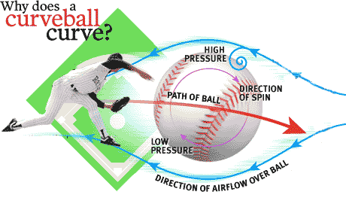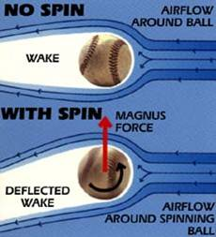

Viscosity

As we already mentioned, real fluids have a certain amount of internal friction called viscosity. It exists in both liquids and gasses and is essentially a frictional force between different layers of fluids the move past one another. Different fluids have different amounts of viscosity. For example, syrup is more viscous than water, grease is more viscous than engine oil. Liquids in general are much more viscous than gasses.

The viscosity of a fluid can be represented quantitatively by the coefficient (η), the greek lowercase “eta”. A thin layer of fluid is placed between two flat plates. The ability of the upper plate with and area (A) to move with a velocity (v) when subjected to a force (F) is given by the following formula:

F = ηA (^{v}/_{l})

Stationary Plate
F
Moving Plate (v)
Fluid
Velocity
gradient
l

The coefficient of viscosity relates to the temperature of the fluid as well. Some common viscosities are:

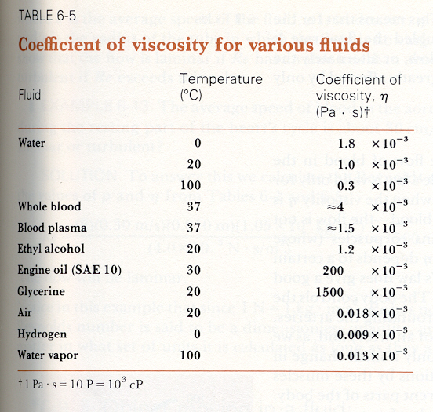

Hand-In Assignment

From Pages 177 - 180 in Giancoli (white copy)

Questions: 3, 4, 6, 8, 9, 11, 12, 13, 14, 16, 17, 18, 20

Problems: 2, 3, 8, 9, 10, 14, 19, 28, 34, 51, 52, 54

